# In search of an interpretative environment for digital traces: the building of Arvest

[cc-by](https://creativecommons.org/licenses/by/4.0/) ©. Published by De Gruyter in cooperation with the University of Luxembourg Centre for Contemporary and Digital History. This is an Open Access article distributed under the terms of the [Creative Commons Attribution License CC-BY](https://creativecommons.org/licenses/by/4.0/)

Multimodal, Annotation, Traces, Historiography, Development

The rise of born-digital materials and the digitization of existing archives is fundamentally changing the nature of sources that humanities researchers work with. As sources transform to multimodal digital traces from which we look to extract data it becomes necessary to also reflect upon the digital environments within which we work. Building upon a decade’s work of digital humanities research and software development, we present Arvest: a tool for interpretative manipulation of digital traces based on IIIF (International Image Interoperability Framework). After a comprehensive state of the art and establishing the theoretical framework that drives development, we shall present the technical specifications of Arvest, and how we intend it to simultaneously propose novel solutions to issues pertaining to working with digital traces and seamlessly integrate with existing tools. We shall also present a case study of research based on a multimodal corpus from the Horizon2020 COESO Project which drove Arvest’s initial development and illustrates some of its core functionalities.

## Introduction

In the humanities, driven by the rise of born-digital materials and the digitization of existing archives, traces are becoming digital -making them a new type of primary source for historians. Digital technology fundamentally changes their ontology: becoming digital, traces have become fragmented, reduced to units of information, data. Digitizing a trace means discretization, making it suitable for calculation and manipulation. That is the fundamental distinction between the analog and the digital trace. Data from traces are no longer traces. They are “*capta*” . Historiography in a digital context is not a revival of quantitative history in the strict sense of the term. It calls first and foremost for practices, and in this practice, the narrative is framed. It is a question of practice that goes beyond simply exposing traces: we expose traces to manipulation, to modeling , and theories and concepts to operationalization . Hence, a paradigm shift is taking place, inviting us to make history differently. Because traces are transformed, they invite a renewal of the critique of the sources we thought we knew and make research questions evolve, leading to other epistemologies. The digital turn revitalizes source criticism, methodological thinking, and narratives, moving beyond traditional methods of close reading to computationally assisted reading and contributing to the general reflection on digital history.

In this context, the digital traces of contemporary events are characterized by their number, multimodality, and fragility. As early as 2003, Roy Rosenzweig warned us: “*Historians, in fact, may be facing a fundamental paradigm shift from a culture of scarcity to a culture of abundance.*” . The unprecedented increase in digital artifacts and data presents specific difficulties highlighted by several actors in digital history. Consider for example the digital archives of a performing arts company, which could contain thousands of files from a single production. These files, varying from images and videos to text and software, encapsulate elements of the performance, its creation, and its reception. The challenges in distinguishing between these different types of data highlight the complexity of working with digital archives. While some traces are easily associated with public reception or final performances, others, such as a rehearsal audio recording, defy simple categorization (is it merely a testimony of a rehearsal, a technical test, or a file used in performance?) and often require direct consultation with the creators for accurate interpretation. Despite the voluminous data available, and while they are of a greater variety and concern phenomena that were previously ‘untraceable’, many aspects remain under-documented. Not all traces can be collected from all collaborators. Certain stages of collaboration leave behind scant traces, such as a few photographs from a workshop or sporadic notes from offstage discussions. Certain parts of digital activity itself rarely result in preserved traces: those occurring on social networks, or during conversations on videoconferencing platforms or applications such as Slack. Lastly, digital traces are fragile: it is estimated today that the average lifespan and readability of a digital file is five years. In a few years, there is no guarantee that we will still be able to open and read certain files, especially those made in proprietary software The loss of traces is a real and inevitable phenomenon: in the past few decades, the number of artists who have already lost not only traces but works due to digital erosion is far too high (see for example in media art and in music ).

Despite the complex characteristics of digital traces, they nonetheless offer the promise of renewed studies. To continue in the context of performing arts studies, digital traces are a paradigm shift not only for the history of theater but also for creative process and aesthetic analysis. To fulfill these promises, we need to build specific tools and environments in order to handle and interpret digital traces in all of their subtleties and complexity. The development of such an environment reveals five primary challenges that must be overcome: to move away from a ‘silo’ approach and allow for the analysis of traces in a multimodal environment; to allow for both manual and automatic annotation of traces, including complex documents like video recordings; to allow for navigation between close reading and distant reading perspectives; to avoid losing context by linking data extraction and the original trace; to reintroduce narrative into visualizations in order to reconcile temporal and spatial representations.

These concerns have guided the development of Arvest, a multimodal environment for linking data and their context, annotating digital traces, and deriving narrative from data. While the starting point for this research and software is the analysis of corpora documenting the creation processes of performances, Arvest is aimed at many disciplines in the humanities and social sciences, especially historians. The goal of this tool is indeed to reconcile traditional hermeneutic approaches with methods from digital history. The application is still under development: as of the writing of this article, a [prototype](https://arvest.tetras-libre.fr/) is available for consultation online, with a first full release planned for the end of 2024. In this paper, we will first revisit the various lab-objects and co-design stages that led to its design. In a second part, we will detail the main epistemological and hermeneutic challenges as well as the technical choices and functionalities implemented. Finally, we will present a case study conducted with Arvest before concluding on future prospects within the framework of the ERC-funded STAGE project.

## Developing lab-objects

One of the major characteristics of digital traces is their experiential nature. To overcome the specific difficulties of digital traces, it is necessary to experiment with and on digital traces. Without action, some elements would not be observable, some objects would not be readable. That is why we rely not only on the methodologies and tools of digital humanities but also on action research by developing our own instruments. Arvest is the continuation of two previous projects, [Rekall](http://www.rekall.fr/) and [MemoRekall](https://memorekall.com/en/), both spaces for questioning themes, methodological tools, and environments in which we create lab-objects. To use Bruno Bachimont’s terms, the lab-object allows us to "*avoid having to choose between an object restricted enough to allow its study and broad enough to observe the effects of its complexity. An artistic production taken as a lab-object presents a locality that neither dilutes nor dissolves its complexity, which remains observable for comprehensive study.*" The lab-object also allows for multidisciplinary work, and in the case of Rekall and MemoRekall, a co-design approach as well as an opening towards citizen science.

### Rekall

As mentioned above, digital traces of works are numerous, and reading each trace is nearly impossible. In the context of performing arts studies, the question thus becomes: what information, what knowledge about the performances is it possible to extract from these traces? Which data should be prioritized to reconstruct a creative process? Contrary to the practice of creating a specific interface for each show, ANON has led a reflection on the design of software that can be applied to as many works as possible . She undertook this project in 2007 as part of the [DOCAM program](https://www.docam.ca) on "Documentation and Conservation of Media Arts" led by the Daniel Langlois Foundation in Montreal, and then worked in collaboration with [Buzzing Light](https://www.buzzinglight.com/) and Thierry Coduys for the development and design of a prototype for Rekall, starting in 2012.

Two main objectives guided the design of Rekall: to help artists document their works so they can be reproduced and thus counteract the obsolescence of digital technologies; to assist researchers in studying the genetics of works in a context of born digital documents and big data. Yet, it is the same materials (traces of the creative process and the works) that are collected, analyzed, and visualized, according to different modalities and timelines. For artists, collection takes place during the creative process itself, progressively through the work stages; it is a living archive, in perpetual motion. The researcher intervenes once the process is completed, once the documents have somewhat stabilized and frozen, and they become traces of what took place. The goal is not to freeze the traces but, on the contrary, to foster a living documentation, which can be augmented, refined (based on contributions from artists, their teams, or researchers and curators) and also interpreted differently depending on research questions that are translated into visualization modes. The accumulation of traces is a key element for the effective operation of Rekall. Indeed, by analyzing these traces and correlating them with each other, Rekall gradually reveals characteristics specific to a given work.

Usual practices of corpus processing separate documents by file types and work in sealed ‘silos’ (texts/images/sounds). Such treatment prevents us from obtaining an overall vision of the collected traces and examining many phenomena, such as the evolution of an idea through different traces, from an image to a text, from a text to a spreadsheet, from a spreadsheet to a video recording. To address this essential issue, Rekall was designed from the start as a multimodal environment that allows an infinite number of traces of different natures to be aggregated in the same interface. Rekall brings together texts, images, sounds, videos, programs, etc. in the same space. Trace analysis is based on the metadata present in each file that allows the extraction of crucial information (author, date of creation, place of creation, keyword, etc.). This information is then used by various data analysis and visualization algorithms to reveal behaviors and practices. By playing with axes and different filters that offer many different perspectives on a given creation, Rekall's functionalities allow for graphical analysis of the work through its traces. These different views allow navigation between the micro and the macro, between close reading and distant reading, between diachronic representation and synchronic representation. In other words, being able to represent a process without erasing its complexity. For a detailed description of the prototype and its interface, we refer to .

### MemoRekall

Initially, Rekall was developed to manage documents within a multimodal framework, enabling the interconnection of various documents. Among these documents, video already held particular importance, with a very first attempt to build an interface in order to add video annotations and to allow comparisons. Video has become an indispensable tool for a variety of research in the humanities. For example, in the field of intangible cultural heritage, videos of cultural practices enable a meticulous study of gestures, expressions, and social interactions. In sociology, recordings of focus groups or everyday life situations provide rich data on behaviors and social dynamics. Similarly, in linguistics, videos of verbal exchanges are essential for studying the nuances of non-verbal and paraverbal communication, such as body language, and facial expressions. In performing arts history, video recordings help to better understand the creative process and build aesthetic analysis of performances . Videos indeed provide invaluable data, however they often need to be accompanied by expert interpretation and contextual information to be fully effective and explicit in conveying their intended insights. While video traces have spread across numerous fields and are used for a variety of purposes, they are rarely self-sufficient: to be explicit, they require commentary.

Taking the importance of video documentation into account, the video annotation functionality in Rekall was spun-off into MemoRekall: a separate, user-friendly web application designed for annotating videos and linking them to other documents or web pages. These annotations and links form a "capsule," a new type of document that can be embedded in websites. Two complementary annotation strategies are allowed: inter-documentary (linking the video to a broader set of documents) and intra-documentary (annotating within the video itself). In the process of making the audiovisual document explicit by adding annotations and links to other documents, the video is ”redocumentarized”. In this way, MemoRekall makes it possible to reappropriate documentary corpora. From a single video, different documentary strategies can be developed, depending on the specific challenges of each capsule author: in the case of performing arts studies, artists need to document their works so that they can be easily distributed, adapted or reenacted; cultural institutions wish to share creative processes with their audiences, as well as elements of analysis on their websites; teachers need to present their students with different multimedia resources to accompany their courses on the history of the performing arts, or as part of educational activities linked to performances seen in class (please see an example capsule below, and for others visit [www.memorekall.com](https://memorekall.com/en/)).

from IPython.display import IFrame  
IFrame('https://project.memorekall.com/en/capsule/preview/hakanai-amcb', width='100%', height='422')

<IPython.lib.display.IFrame at 0x7f59ec285bd0>

### A co-design approach grounded in citizen science

Such projects as Rekall and MemoRekall often fall somewhere on a spectrum between two approaches: on the one hand, the development of tools within the context of a specific research project that look to interrogate a specific corpus and that are designed to investigate specific epistemological questions; on the other, the development of more generic working environments which have a certain user profile in mind but do not base themselves around a specific use-case during development. In the former case, the tools that emerge can be characteristically project-specific, and can only be further applied in a restrained number of contexts; in the latter, tools runs the risk of allowing for functionalities and workflows that can appear useful in concept, but which crumble when applied to actual case-studies. This polarity illustrates the tensions that can arise when researchers and programmers meet to work in collaboration on a project.

This spectrum is a caricature – projects will inevitably find themselves somewhere along this gauge without reaching either of its extremities – but it is a useful idea to bear in mind when planning and executing projects that see academic, computer science and citizen profiles coming together to collaborate and create “*interdisciplinary trading zones*” . There are numerous examples in recent years where this balance would appear to have been achieved: for example the ERC-funded [FluCoMa project](https://www.flucoma.org/) lead by Pierre Alexandre Tremblay at the University of Huddersfield saw computer scientists working closely with creative coders to bring a toolkit of machine learning algorithms and sound corpus manipulation tools to a number of creative coding environments; another is Taylor Arnold and Lauren Tilton’s [Distant Viewing Lab](https://distantviewing.org/) at the University of Richmond which produced a python package for distant viewing in the digital humanities across a number of research projects with the intention of making their tool accessible to non techno-fluent researchers through a high-level command line interface.

Following a design thinking methodology , Rekall and MemoRekall have emerged from a development process centered on collaboration and co-design. This approach aligns with the principles of citizen science, a practice where scientific research is conducted, in whole or in part, by amateur or nonprofessional scientists. Workshops have been carried-out in different contexts that were structured specifically to engage with users’ needs following the UK Design Council’s Double Diamond Framework: workshops were divided into exploration and development phases, where users first discover the tool and define their needs, then these needs are developed and delivered back to the users at which point the process can start again. Working in this way allows us to understand how the tools we have developed are understood by the users, meet interface and functionality needs that may have been opaque to the developers, and ground the tools in real use.

By involving a diverse group of stakeholders, including non-experts, in the research process, Rekall and MemoRekall not only benefit from a wide range of perspectives and expertise but also foster a sense of ownership and engagement among participants. For example, over the years, MemoRekall has been developed in the context of various citizen-science research projects, such as the Erasmus+ funded COSMIC project and the Horizon2020 funded COESO project . In each instance, user feedback (professional circus teachers, choreographers, students from high school to MA) was meticulously considered and incorporated into the tool, addressing aspects ranging from interface design and user experience to specific functionalities and workflows. In the context of the COSMIC project, the application was tailored to the needs of circus education. This adaptation process involved close collaboration with circus educators and practitioners to identify and integrate features that support the complex and dynamic nature of circus training. Specific functionalities (slow motion, visual annotation) were developed to facilitate the detailed analysis of physical movements and the documentation of training routines. This collaborative work has yielded its fruits, and MemoRekall is now widely used by researchers, artists, cultural professionals, teachers and schoolchildren.

### From MemoRekall to Arvest

In the context of the [COESO project](https://dansophie.hypotheses.org), the co-design approach led us to reconsider the video centric approach of MemoRekall and more braodly its development in the context of FAIR principles. During the work sessions on documenting the collaboration between a choreographer and dancer (Cosetta Graffione) and a philosopher (Stefania Ferrando), we concluded with Irénée Blin (Laban notator on the project) that video could no longer be the central document for annotation work. Instead, we needed to consider a network of multimodal documents that could annotate each other, as well as a means of changing perspective by opening documents that can be used as new entry points into the annotation network. Based on this observation, a researcher (ANON), a team of developers (ANON), a Laban notator (Irénée Blin) and a post-doc (ANON) worked together to improve the MemoRekall application and provide a prototype for a new version of the software: the development of a multimodal annotation editor to link a video recording to its Laban notation and vice-versa.

This new conceptual approach and these new functionalities required a complete reimplementation of the tool. In order to base this reimplementation on open standards, the [W3C Web Annotation Guidelines](https://www.w3.org/TR/annotation-model/) provided an extensible data model and protocol for multimodal annotation across the World Wide Web. In addition, these W3C recommendations are endorsed by the [IIIF (International Image Interoperability Framework)](https://iiif.io/) initiative, which is receiving increasing attention from museums and other cultural institutions distributing digital content. For example, [Europeana](https://www.europeana.eu), which is a data source for the annotations initially targeted in the COESO project, uses IIIF to distribute its content.

Therefore, in order to meet COESO's objectives, we decided to implement Memorekall-IIIF, a prototype for multimodal annotation that capitalizes on Memorekall's experience and communities, but is also based on IIIF's open standards. The tool is based on the IIIF [Mirador viewer](https://github.com/ProjectMirador/mirador) and can be extended via themes and plugins to suit specific community needs. The prototype, a COESO-based example and a sandbox are presented on this web page: <https://gitlab.tetras-libre.fr/iiif/POC-mirador>. This prototype was the basis for what has now become Arvest. Its functionalities and the choice of the IIIF are described in the second part of this paper.

### Evaluating Video Annotation Tools: A Comparative Study

One of the first objectives of Arvest is the building of an effective video annotation tool for digital humanists based on the IIIF protocol and MemoRekall functionalities. In our study, we analyzed 51 video annotation tools focusing on multiple aspects such as supported storage services, annotation types, cooperation features, sharing capabilities, interoperability, extensibility, usage mode, business model, and governance.

!pip install pandas

Requirement already satisfied: pandas in /opt/conda/lib/python3.11/site-packages (2.2.2)  
Requirement already satisfied: numpy>=1.23.2 in /opt/conda/lib/python3.11/site-packages (from pandas) (1.26.4)  
Requirement already satisfied: python-dateutil>=2.8.2 in /opt/conda/lib/python3.11/site-packages (from pandas) (2.9.0)  
Requirement already satisfied: pytz>=2020.1 in /opt/conda/lib/python3.11/site-packages (from pandas) (2024.1)  
Requirement already satisfied: tzdata>=2022.7 in /opt/conda/lib/python3.11/site-packages (from pandas) (2024.1)  
Requirement already satisfied: six>=1.5 in /opt/conda/lib/python3.11/site-packages (from python-dateutil>=2.8.2->pandas) (1.16.0)

import pandas as pd  
from IPython.display import HTML  
  
# Define the columns  
columns = [  
 "Software", "Supported storage / streaming services",   
 "Annotation modalities", "Cooperation features", "Sharing capabilities",   
 "Interoperability", "Extensibility", "Local vs. online usage",   
 "Business model", "Governance"  
]  
  
# Define the data (rows), including lists and hyperlinks  
data = [  
 ["The name of the software",   
 "The website where the software can be accessed",   
 "Where is the interrograted media stored (a service like Youtube, dedicated server, local machine etc.)",   
 "Ways in which the user can add annotations, types of annotations",   
 "Ways in which the documents can be worked on by several people",   
 "Ways in which the documents can be shared",   
 "Can the resulting documents and projects be opened in other programs, accessed by other frameworks. Openness of format",   
 "Is it possible to etend the environment (write plugins etc.",   
 "How can projects be sorted (cloud, local machine etc.)",   
 "Is the service free to use, open source, paid, subscription based etc."],  
   
 ["<a href='https://website1.com'>MemoRekall</a> (legacy)",   
 "<ul><li>Youtube</li><li>Vimeo</li></ul>",   
 "<ul><li>types of annotations: documents (pdf, image, etc); text; urls</li> <li>annotations have metadata</li> <li>can control the speed of video playback</li>",   
 "Projects can have several authors",   
 "Projects can be <ul><li>shared via a link,</li> <li>embedded in a website,</li> <li>or saved to XML</li></ul>",   
 "Projects exported as XML file.",   
 "-",   
 "<ul><li>Online storage with HumaNum</li> <li>XML files can be stored locally</li> <li>no way of uploading downloaded XML files</li></ul>",   
 "<ul><li>Open source, free to use</li> <li>Account required</li></ul>",   
 "Project led by Clarisse Bardiot, Université Rennes 2"],  
  
 ["<a href='https://videonotes.net/'>Videonotes</a>",   
 "Youtube",   
 "<ul><li>type textual notes during playback</li> <li>hit enter and the annotation will be created</li> <li>list is populated under the video</li></ul>",   
 "-",   
 "-",   
 "-",   
 "-",   
 "online storage",   
 "<ul><li>free to use</li> <li>account required</li></ul>",   
 "-"],  
  
 ["<a href='https://videonotes.net/'>VideoAnt</a>",   
 "Youtube",   
 "<ul><li>add textual annotations</li> <li>each annotation is a conversation thread which can be responded to</li></ul>",   
 "users can edit the same project and respond to each other's annotations",   
 "projects can be shared <ul><li>via link,</li> <li>embedded in HTML</li> <li>and saved to various formats</li> <li>can create groups of users</li></ul>",   
 "text, RSS, XML and JSON export formats",   
 "-",   
 "<ul><li>online storage</li> <li>projects can be downloaded but not uploaded</li></ul>",   
 "<ul><li>free to use</li> <li>account required</li></ul>",   
 "University of Minnesota"],  
   
 ["<a href='https://www.vibby.com/'>Vibby</a>",   
 "Youtube",   
 "<ul><li>select parts of the video and comment them with text</li> <li>these can be subject to comment from other people</li> <li>Work on multiple videos in a same project</li> <li>the annotated fragments will constitute the final project",   
 "users can respond, comment and upvote the projects and annotations",   
 "<ul><li>share via the Vibby website</li> <li>give the project a tag and other metadata</li> <li>allows share via link and embed in HTML</li></ul>",   
 "-",   
 "-",   
 "online storage",   
 "<ul><li>free to use</li> <li>account required</li></ul>",   
 "-"],  
  
 ["<a href='https://yinote.co/'>YiNote</a>",   
 "Any service with HTML video (Youtube, Vimeo, LinkedIn, Lynda, Coursera etc.)",   
 "<ul><li>browser extension</li> <li>add textual annotations during video playback</li> <li>these can be interacted with to play the video from that moment</li> <li>global overview page is created and associated with a screenshot of the anntoation which can be edited (add shapes, text etc.)</li>/ul>",   
 "-",   
 "export to JSON, PDF, markdown, google docs, everntoe etc.",   
 "exportable to a number of different formats",   
 "<ul><li>possibility to download and upload data files</li> <li>the git repository is available for forking (very well documented)</li></ul>",   
 "online and local storage",   
 "<ul><li>free to use, open source</li> <li>no account required</li></ul>",   
 "Github community"],  
  
 ["<a href='https://www.timeline.ly/'>Timelinely</a>",   
 "Youtube",   
 "add timed annotations linked to images, google maps, text, urls, video and photo",   
 "-",   
 "share via a link",   
 "-",   
 "-",   
 "online storage",   
 "<ul><li>free to use</li> <li>no account required</li></ul>",   
 "small development team"],  
  
 ["Vizia - redirect to teachable.com, depreciated",   
 "Youtube",   
 "create text, url, quizz and question annotations, designed for data collection",   
 "-",   
 "share projects with url",   
 "-",   
 "-",   
 "-",   
 "-",   
 "-"],  
  
 ["<a href='https://www.verse.com/'>Verse</a>",   
 "upload your own video content (max 30Mo/month for basic account), includes 360° video",   
 "<ul><li>Create interactable projects with parts of the video which can be clicked on and using simple logic and decision points trigger other video playback</li> <li>Annotations can be text, image and url</li></ul>",   
 "-",   
 "embeddable",   
 "-",   
 "API and plugin integration",   
 "Online storage",   
 "<ul><li>Free to use</li <li>account required</li> <li>premium accounts</li></ul>",   
 "Professional development team (Bonza Interactive Group)"],  
  
 ["<a href='https://foundation.mozilla.org/en/artifacts/popcorn-maker/'>Popcorn Maker</a> - depreciated",   
 "HTML video",   
 "Remix web video with text, image, google maps, wikipedia annotations using a layed timeline",   
 "-",   
 "-",   
 "-",   
 "Built upon the popcorn.js library",   
 "-",   
 "-",   
 "Mozilla"],  
  
 ["Videopath - depreciated",   
 "Youtube",   
 "Add text, image, url and audio annotations onto a vertical timeline",   
 "-",   
 "Embeddable",   
 "-",   
 "-",   
 "-",   
 "-",   
 "-"],  
  
 ["<a href='https://hihaho.com/'>Hihaho</a>",   
 "<ul><li>upload your own video</li> <li>or upload from Youtube, Vimeo, JW Player, Qumu, Panopto, Mediasite or Blue Billiwig</li></ul>",   
 "Create interactive videos using simple logic with button, menus, adding images, text etc.",   
 "-",   
 "Embeddable, share via url",   
 "-",   
 "Backend API",   
 "Online storage",   
 "<ul><li>free to use</li> <li>account required</li> <li>premium accounts</li></ul>",   
 "Professional development team"],  
  
 ["<a href='https://edpuzzle.com/'>Edpuzzle</a>",   
 "<ul><li>upload or record video</li> <li>allows Youtube and Vimeo</li></ul>",   
 "Create pedagogical interactive videos - add quizzes, text, voice recordings etc.",   
 "-",   
 "<ul><li>Integration with LMS services such as Google Classroom, Microsoft Teams, Canvas, Schoology, Moodle, Blackboard, Blackbaud, Powerschool, Clever and D2L</li> <li>create classes in Edpuzzle</li></ul>",   
 "-",   
 "-",   
 "Online storage",   
 "<ul><li>free to use</li> <li>account required</li> <li>premium accounts for teachers and schools</li></ul>",   
 "Professional development team"],  
  
 ["<a href='https://mindstamp.io/'>Mindstamp</a>",   
 "<ul><li>Youtube</li><li>Vimeo</li><li>Wistia</li><li>Kaltura</li><li>Dropbox</li><li>Amazon S3</li><li>Cloudinary</li><li>JWPlayer</li></ul>",   
 "Create interactive videos with button, questions, drawings comments, images, audio and video, conditional logic, chapters etc.",   
 "-",   
 "Data analysis integrations with Hubspot, Salesforce, Zapier, Google Analytics, Segment, Constant Contact",   
 "-",   
 "Backend REST API and webhooks",   
 "Online storage",   
 "Free trial, but paid accounts required",   
 "Professional development team"],  
  
 ["<a href='http://www.advene.org/'>Advene</a>",   
 "Local videos",   
 "<ul><li>downloadable program</li> <li>multiple interfaces for adding annotations</li> <li>define bookmarks, hyperlinks, files, text, SVG</li> <li>control video playback with annotations</li></ul>",   
 "-",   
 "Export to multiple formats: SLIL, SVG, HTML+CSS, XML",   
 "Export and import various formats",   
 "Git repo and documentation available",   
 "Local storage",   
 "Free to use, must be downloaded",   
 "LIRIS laboratory of University Claude Bernard Lyon 1"],  
  
 ["<a href='https://celluloid.huma-num.fr/'>Celluloid</a>",   
 "<ul><li>Youtube</li><li>Peertube</li></ul>",   
 "<ul><li>Define metadata for the project.</li> <li>Create annotations by defining the time, if the video will pause, and a text.</li></ul>",   
 "A project can have several members working on it.",   
 "Embeddable and share via url.",   
 "-",   
 "Git repo available with documentation",   
 "Online storage",   
 "Free to use, account required",   
 "Canevas consortium (Michaël Bourgatte and Laurent Tessier)"],  
  
 ["<a href='https://github.com/ksnip/ksnip'>Ksnip</a>",   
 "-",   
 "<ul><li>take screenshot and annotate with various drawing tools</li> <li>possibility also to blur and pixelate images</li></ul>",   
 "-",   
 "<ul><li>Integrated uploading to imgur</li> <li>PDF and PS export</li></ul>",   
 "PS image export.",   
 "Git repo available for forking",   
 "Local storage",   
 "<ul><li>Free to use, open source</li> <li>no account required</li></ul>",   
 "Github development community"],  
  
 ["<a href='https://www.vialogues.com/'>Vialogues</a> - depreciated (site down for maintenance at time of writing)",   
 "<ul><li>upload videos (1GB or less)</li><li>Youtube</li><li>Vimeo</li></ul>",   
 "<ul><li>define a main question as a description, then users can add textual comments at given time points in the video</li> <li>the user can also add polls as annotations</li></ul>",   
 "Multiple users can interact with the project and add comments.",   
 "Url sharing and embeddable.",   
 "-",   
 "-",   
 "Online storage",   
 "<ul><li>Free to use, account required.</li></ul>",   
 "EdLab at Columbia University"],  
  
 ["<a href='https://motionbank.org/'>Motion Bank (Piecemaker/PM2GO)</a>",   
 "<ul><li>Youtube</li><li>Vimeo</li></ul>",   
 "<ul><li>add timed textual annotations</li> <li>concept of 'timelines', allowing for multiple videos in a same project</li></ul>",   
 "Possibility to create groups and invite members to work on projects.",   
 "Sharing only seems possible between members.",   
 "-",   
 "-",   
 "Online storage",   
 "<ul><li>Free to use, account required</li> <li>accounts created on request</li></ul>",   
 "Mainz University of Applied Sciences"],  
  
 ["<a href='https://www.w3.org/2008/WebVideo/Annotations/'>Media Annotations Working Group</a>",   
 "Web video",   
 "Creation of an ontology and API designed to facilitate cross-community data integration of information related to media objects in the web",   
 "-",   
 "-",   
 "This was the goal of the project.",   
 "All results are open source and adoptable",   
 "-",   
 "Open source",   
 "Media Annotations Working Group"],  
  
 ["<a href='https://medialab.sciencespo.fr/en/tools/dicto/'>Dicto (Medialab)</a>",   
 "Web video and audio (Youtube, Vimeo, Soundcloud etc.)",  
 "<ul><li>create collections of documents as corpora</li> <li>segment the documents, give them metadata, comment them (notably designed to work for transcription)</li></ul>",  
 "-",   
 "Downloadable to various formats (including HTML webpage).",   
 "Download to HTML, json and various lists as tsv format",   
 "Source code available on Github",   
 "Online and local storage",   
 "<ul><li>Free to use</li> <li>can be downloaded as a local desktop application</li></ul>",   
 "Robin de Mourat and Donato Ricci"],  
  
 ["<a href='https://iiif.io/'>IIIF: International Image Interoperability Framework</a>",   
 "Web video",   
 "IIIF is a standard for interoperability and sharing digital artefacts. It is an API, a set of standards, and has various applications that can interpret its data (Mirador, UniversalViewer etc.)",   
 "-",   
 "-",   
 "This is the goal of the project",   
 "Open source and available on Github.",   
 "-",   
 "Open source",   
 "IIIF Consortium (65 institutional members)"],  
  
 ["<a href='https://go.coachseye.com/retirement/'>Coach's Eye</a> - depreciated",   
 "Local video",   
 "Possibility to slow down video and draw annotations directly onto it (destined for coaches and athletes)",   
 "-",   
 "Coaches can distribute projects to their team's devices.",   
 "-",   
 "-",   
 "-",   
 "Free to use.",   
 "Professional development team (TechSmith)"],  
  
 ["<a href='https://motion-notes.di.fct.unl.pt/'>MotionNotes</a>",   
 "<ul><li>Local video</li><li>Youtube</li><li>Europeana</li><li>WeaveX</li></ul>",   
 "<ul><li>layered timeline interface</li> <li>add various types of annotations - drawing, text, voiceover, links, 3D objects</li> <li>control the speed of playback</li></ul>",   
 "-",   
 "Embeddable and url sharing.",   
 "-",   
 "-",   
 "Online and local storage",   
 "Free to use, account required",   
 "Universidade NOVA de Lisboa"],  
  
 ["<a href='https://pro.europeana.eu/page/enhanced-unified-playout-service'>Enhanced Unified Playout</a>",   
 "Europeana videos",   
 "<ul><li>create segmentations and playlists of Europeana videos</li> <li>add annotations like text, subtitles, speech bubbles to the video</li></ul>",   
 "-",   
 "Create embeddable codeboxes.",   
 "Up to IIIF, W3C, HTML5 standards",   
 "Source code available on Github",   
 "Online storage",   
 "Free to use, account required",   
 "Europeana"],  
  
 ["<a href='https://jarvis.playment.io/'>Playment</a>",   
 "Local videos",   
 "<ul><li>create visual annotations for labelling content in the video: 2D boxes, 3D cubes, point clouds etc.</li> <li>used for building up models for ML algorithms</li></ul>",   
 "Collaborative building of datasets.",   
 "-",   
 "-",   
 "-",   
 "-",   
 "Paid usage.",   
 "Professional development team"],  
  
 ["<a href='https://kinolab.org/'>KinoLab</a>",   
 "Local videos",   
 "Upload videos to the platform and create labels and tags in order to create a large database open to researchers",   
 "The platform is built up collaboratively with all users.",   
 "-",   
 "-",   
 "-",   
 "Online storage",   
 "Free to use, account required",   
 "Bowdoin College"],  
  
 ["<a href='https://omeka.org/'>Omeka</a>",   
 "Local videos",   
 "<ul><li>create collections in the style of media archives</li> <li>tool for building up virtual collections of archives, virtual visits etc.</li></ul>",   
 "-",   
 "Export to a number of different formats",   
 "Uses industry standards such as Dublin Core",   
 "Open source and source code available on Github",   
 "Local storage",   
 "Free to use, download required",   
 "Digital Scholar (cf. Zotero)"],  
  
 ["<a href='https://rclmediate.lib.rochester.edu/'>Mediate</a>",   
 "Local videos and audio",   
 "<ul><li>add annotations to content based on a 'schema', identifying specific content</li> <li>each note can be a thread that can be commented by other users</li></ul>",   
 "Define collaborators to work on the project",   
 "-",   
 "-",   
 "REST API",   
 "Online storage",   
 "Free to use, account required",   
 "University of Rochester"],  
  
 ["<a href='https://mediaecology.dartmouth.edu/sat/'>Semantic Annotation Tool</a>",   
 "Web videos",   
 "<ul><li>create textual annotations with tags</li> <li>it is the combination of two open source libraries: Waldorf.js and Statler</li> <li>the project offers an end-to-end open source video annotation workflow designed to be incorporated into other projects</li></ul>",   
 "-",   
 "-",   
 "W3C Open Annotation spec",   
 "Both Waldorf.js and Statler are open source and available on Github.",   
 "-",   
 "Open source, free to use",   
 "Media Ecology Project"],  
  
 ["<a href='https://www.recolnat.org/fr/annotate'>Annotate-On</a>",   
 "<ul><li>Local images or video</li><li>Images from Recolnat</li></ul>",   
 "<ul><li>various tools for adding visual highlights to an imagea/li> <li>tools like annotations which represent the counting of elements in an image</li></ul>",   
 "Possibility to share a project across several machines",   
 "<ul><li>share the project across machines</li> <li>export projects to CSV and IIIF to make available on Recolnat</li></ul>",   
 "CSV and IIIF export.",   
 "-",   
 "<ul><li>Local storage</li><li>Storage on Recolnat</li></ul>",   
 "Open source, free to use (must cite)",   
 "Recolnat"],  
  
 ["<a href='https://geomedialab.org/atlascine.html'>Altasciné</a>",   
 "Local video or audio is uploaded to the app.",   
 "<ul><li>bespoke interface which needs a transcript of the audio or video file (designed to work with interviews)</li> <li>link to the text of the transcript tags and places on a map</li> <li>this creates data that can be viewed in various perspectives</li></ul>",   
 "Possibility for several accounts to have access to an Atlas",   
 "Share the link to the Atlas (can be password protected)",   
 "-",   
 "<ul><li>Well-documented on the git repo</li> <li>entire code base can be forked and deployed</li></ul>",   
 "Online storage.",   
 "Open source, free to use (account required)",   
 "Geomedia Lab, Concordia University"],  
  
 ["<a href='https://educ.arte.tv/'>educARTE</a>",   
 "Arte videos",   
 "Create network visualizations of different types of documents: arte videos, PDFs, and links",   
 "Embedded within the French school system. Projects can be viewed by teachers and classmates.",   
 "Share projects within the educarte system.",   
 "-",   
 "-",   
 "Online storage.",   
 "<ul><li>Free to test</li> Contracts are made available to educational institutions</li></ul>",   
 "Small development team"],  
  
 ["<a href='https://otranscribe.com/'>oTranscribe</a>",   
 "<ul><li>Local audio or video files</li><li>Youtube</li></ul>",   
 "<ul><li>Tool for helping with transcription</li> <li>Create a text document while watching the video</li> <li>Keyboard shortcuts allow for playback control</li> <li>Video speed control</li></ul>",   
 "Share files directly on Google Drive.",   
 "-",   
 "Export and import of markdown and plain text.",   
 "-",   
 "Online usage, offline storage.",   
 "Free to use.",   
 "Single developer for the MuckRock foundation"],  
  
 ["<a href='http://www.sonal-info.com/'>sonal</a>",   
 "Local video and audio",   
 "<ul><li>Perform segmentations, and add textual annotations in a layered timeline</li> <li>Augment transcriptions with speaker attribution</li> <li>Text formatting (bold, italic etc.)</li> <li>Give tags to different segments</li> <li>Basic NLP analyses and data-driven interfaces derived from this data</li></ul>",   
 "-",   
 "-",   
 "Import and export various text formats. Windows XP and 8 only",   
 "Code not available.",   
 "Local usage.",   
 "Free to download and use.",   
 "CAQDAS. 2 developers"],  
  
 ["<a href='https://opennewslabs.github.io/autoEdit_2/'>autoEdit</a>",   
 "Local video.",   
 "<ul><li>Tool for speech-to-text transcription</li> <li>Add a video, then choose a speech-to-text algorithm</li> <li>The transcription is time-linked</li></ul>",   
 "-",   
 "-",   
 "<ul><li>Export as EDL, or srt format</li> <li>Can also export to bespoke video editors</li></ul>",   
 "Free and open source, code is available on Github.",   
 "Local usage.",   
 "Free and open source.",   
 "OpenNews Labs"],  
  
 ["<a href='https://frametrail.org/'>FrameTrail</a>",   
 "HTML5 video.",   
 "<ul><li>Place documents on top of the video (text, image, web pages, interactive maps)</li> <li>add javascript code snippets to be executed at certain points of the video</li> <li>Content can be viewed in-time or as non-linear networks of video fragments which can be navigated freely</li></ul>",   
 "Compare your project with the annotation timelines of other users.",   
 "-",   
 "Proprietary format only.",   
 "Open source, code is available on Github and forking is encouraged.",   
 "Local usage (must be run on a local web server).",   
 "Free and open source.",   
 "Merz Akademie, Stuttgart"],  
  
 ["<a href='https://scenari.software/fr/'>scenari</a>",   
 "Local video and audio.",   
 "<ul><li>A tool for creating textual content that can be augmented in various ways (adding video, audio, image, quiz etc.)</li> <li>The content can then be exported in various formats (web, pdf, xml, ePub etc.)</li></ul>",   
 "Integrated cooperation tools with solutions for todo lists, proof-reading workflow etc.",   
 "Export projects to a number of different formats (web page, pdf, xml, ePub etc.).",   
 "Multiple export functionalities lead to interoperability.",   
 "Designed with extensibility in mind, possibility to edit the ways in which are exported.",   
 "Local storage (or online if you use the client-server version of the tool).",   
 "Free to use.",   
 "Kelis"],  
  
 ["<a href='http://piim.newschool.edu/entitymapper/'>Entity Mapper</a>",   
 "-",   
 "Visualize ATLAS.ti format data with different visualizations, notably network visualizations",   
 "-",   
 "-",   
 "Open source and available on github.",   
 "Local usage (download required).",   
 "Free to use and open source.",   
 "The Parsons Institute for Information Mapping"],  
  
 ["<a href='https://www.iri.centrepompidou.fr/outils/lignes-de-temps/'>Lignes de temps</a> - depreciated",   
 "<ul><li>Local videos</li><li>Youtube</li><li>URL</li></ul>",   
 "<ul><li>Create segments for the video which have a number of metadata (title, tags, description, colour etc.)</li> <li>Can also add an audio file to a segment</li></ul>",   
 "-",   
 "Publish the project within the IRI community.",   
 "-",   
 "-",   
 "Free to use. Account required",   
 "Institut de Recherche et d'Innovation"],  
  
 ["<a href='https://etalk.vital-it.ch/'>eTalks</a>",   
 "Local audio and image.",   
 "Create interactive presentations of slides based on three components: a text, an audio recording of the text, and image",   
 "-",   
 "Share via direct link or HTML embed code.",   
 "-",   
 "Available open source on Github.",   
 "Online storage.",   
 "Open source, free to use.",   
 "Swiss Institute of Bioinformatics"],  
  
 ["<a href='http://antiboredom.github.io/videogrep/'>Videogrep</a>",   
 "Local video.",   
 "A command line tool (that can be used in python) for create composite videos from subtitle files and textual transcriptions",   
 "-",   
 "-",   
 "Export to various video formats, including bespoke video editors.",   
 "Open source and available on Github.",   
 "Local storage.",   
 "Open source, free to use.",   
 "Single developer (Sam Mavigne)"],  
  
 ["<a href='http://ucbvislab.github.io/speecheditor/'>Speech Editor</a>",   
 "Local audio",   
 "Interactively edit audio from text transcriptions (cut audio, add pauses breaths etc.)",   
 "-",   
 "-",   
 "-",   
 "Open source and available on Github.",   
 "Local storage",   
 "Open source, free to use",   
 "UC Berkely"],  
  
 ["<a href='https://github.com/strob/interlace'>InterLace</a>",   
 "HTML5 video.",   
 "<ul><li>A node module for creating interactive timelines of videos with limited textual annotation</li> <li>The tool renders zoomable timelines that give a preview of each frame, allowing the user to gain a comprehensive image of the video contents</li></ul>",   
 "-",   
 "Export to a viewable only format",   
 "-",   
 "Open source and available on Github",   
 "Local usage",   
 "Open source, free to use.",   
 "Single developer (Robert M Ochshorn) at Jan van Eyck Academie"],  
  
 ["<a href='https://macdownload.informer.com/f5-transcription-free/'>F5</a>",   
 "Local video and audio",   
 "A transcription tool with variable media playback speed, timestamps and speaker tokens",   
 "-",   
 "-",   
 "-",   
 "-",   
 "Local usage.",   
 "Free to download.",   
 "Dr. Dresing & Pehl GmbH"],  
  
 ["<a href='https://www.descript.com/'>Descript</a>",   
 "Local video and audio.",   
 "<ul><li>A tool for creating videos based on transcription similar to speech editor</li> <li>Remove filler words, perform audio and video editing manipulations</li> <li>Annotate video with backgrounds and inserting images</li></ul>",   
 "-",   
 "<ul><li>Can publish interactive transcripts to the web and allow for commenting</li> <li>Share direct link or embeddable HTML</li></ul>",   
 "-",   
 "-",   
 "Local usage.",   
 "Free trial with paid premium options.",   
 "100+ team"],  
  
 ["<a href='https://openparliament.tv/?lang=en'>Open Parliament TV</a>",   
 "-",   
 "<ul><li>A project that provides an interface for navigating parliamentary debates</li> <li>Videos are coupled with interactive transcripts, and annotated with links to documents when necessary</li></ul>",   
 "-",   
 "Allows for citation of fragments of parliamentary debates",   
 "Access data via API calls",   
 "Open source and available on Github",   
 "Online usage",   
 "<ul><li>Open source, everything is available on Github</li></ul>",   
 "<ul><li>Open parliament TV (development team, size unknown)</li></ul>"],  
  
 ["<a href='https://www.4science.com/dspace-glam/'>Dspace</a>",   
 "Local media content",   
 "Dspace is a suite of different tools for digital asset management and online dissemination. It functions with a number of add-ons, notably a IIIF Image viewer and OCR tools for manuscript analysis.",   
 "Dependent on add-on.",   
 "One of the primary goals of Dspace is for digital dissemination of content in various forms.",   
 "Some of the outputs are interoperable, for example IIIF.",   
 "-",   
 "Local and online usage.",   
 "Based on open source technologies. However, no available download, you must pay to have Dspace set up the systems your institutions requires.",   
 "Space, a large development company"],  
  
 ["<a href='https://prezi.com/'>Prezi</a>",   
 "Local media.",   
 "<ul><li>Create interactive presentations, much like powerpoint, but online</li> <li>Possibility to include various media formats</li> <li>Presentations can be based on video with animated images annotating the main resource</li></ul>",   
 "Possibility to share presentations between accounts and reuse presentations.",   
 "Share as embeddable code on the web or direct link.",   
 "-",   
 "-",   
 "Online usage.",   
 "Free trial, then paid usage.",   
 "Large developer team"],  
  
 ["<a href='https://www.loom.com/fr'>Loom</a>",   
 "In-app screen capture.",   
 "<ul><li>Annotate screen captures in various ways, notably inserting images onto the screen.</li></ul>",   
 "Projects are shared amongst teams, and there is support for commenting, reactions etc.",   
 "<ul><li>Share with various permissions</li> <li>share to social media</li> <li>embed codes</li>",   
 "-",   
 "-",   
 "Online usage.",   
 "Free trial, then paid usage.",   
 "Large developer team"],  
  
 ["<a href='https://av.tib.eu/'>TIB AV-Analytics</a>",   
 "Local video is uploaded and stored on the platform",   
 "<ul><li>Various machine learning-driven analyses (shot-detection, scene recognition etc), the results of which get displayed on different timelines</li> <li>Timelines can also be created manually</li></ul>",   
 "Videos can be shared with other users.",   
 "-",   
 "Export ML-derived data to various formats.",   
 "Certain parts of the code are available on Github.",   
 "Online storage",   
 "Free to use",   
 "Deutsche Forschungsgemeinschaft – German Research Foundation (DFG). Small research team"],  
  
 ["<a href='https://mediasuite.clariah.nl/'>CLARIAH Media Suite</a>",   
 "Exploit data from a number of Dutch audiovisual archives",   
 "The platform offers a number of tools for distant reading, searching etc.",   
 "Projects can be shared between users",   
 "-",   
 "The tool can produce raw data which can be exploited in any number of ways",   
 "Projects are driven by Jupyter Notebooks, thus are inherently extensible",   
 "Cloud and local storage.",   
 "Free to use for people detaining certain university credentials.",   
 "CLARIAH research infrastructure, large research team"]  
]  
  
# Create the DataFrame  
df = pd.DataFrame(data, columns=columns)  
  
# Reindex to start from 1  
df.index = df.index + 1  
  
# Display the DataFrame with formatted HTML (to keep links clickable and lists working)  
HTML(df.to_html(escape=False))

<IPython.core.display.HTML object>

Most of the video annotation tools analyzed support YouTube as the primary storage service. Tools like MemoRekall and Hihaho also support other services such as Vimeo. Additionally, some software like Advene and Omeka allow for local storage, providing extra flexibility for users who prefer to work offline.

Textual annotations are the most common among the tools studied. However, some software goes beyond by offering advanced annotations such as inserting images, URLs, and interactive elements. For instance, Timelinely allows timed annotations linked to images, Google maps, text, and URLs. Edpuzzle stands out by enabling the addition of quizzes, text, and voice recordings, making it a comprehensive educational tool for creating interactive videos.

Collaboration is an important feature for many tools. MemoRekall and VideoAnt enable multiple users to work on the same project, facilitating team collaboration and co-creation of annotated content. However, other tools do not offer specific cooperation features, which can limit their use in collaborative contexts.

Most tools offer sharing options via direct links or HTML embedding. VideoAnt, for example, allows projects to be shared via links, embedded in HTML pages, and exported in various formats. YiNote is notable for its export capabilities to multiple formats such as JSON, PDF, and markdown, making it easier to share and integrate annotations across different platforms.

Interoperability is an area where many tools have limitations. A few tools, such as YiNote and Mindstamp, allow export to standardized formats or integration with other platforms. Extensibility through plugins or APIs is not widely available but is present in some tools like Verse and Hihaho, offering users the ability to customize and enrich the core functionalities according to their specific needs.

The tools also vary in terms of usage mode. Some are strictly online, such as FrameTrail and Loom, while others, like autoEdit and Entity Mapper, can be used locally.

The majority of tools are free to use, although some require account creation. Others offer premium features or are entirely paid services, like Mindstamp and Dspace.

The tools are developed by a variety of entities, ranging from academic institutions, such as MemoRekall (Université Rennes 2) and VideoAnt (University of Minnesota), to professional development teams and open-source communities. This diversity in governance often influences development priorities, support quality, and the sustainability of the tools.

## Arvest, an environment to interpret digital traces

The survey on video annotation tools, although not exhaustive, reveals that no existing solutions fully meet all the requirements necessary for humanities research. On a practical level, these requirements include: storage services such as YouTube, Vimeo and PeerTube, as well as public and private video facilities; a wide range of annotation possibilities (aside the document or as overlays, textual and visual annotations, and the ability to link to web pages and documents); collaboration features; sharing options on the web and import/export in various formats (CSV, JSON, XML); interoperability and, more generally, adherence to FAIR principles; extensibility through plugins or APIs.

On a more general level, the passage from MemoRekall to Arvest shows how difficult digital traces are to interpret and thus the necessity of an “*interpretative interface*”, which Johanna Drucker describes as supporting “*acts of interpretation rather than simply returning selected results from a pre-existing data set.*” It “*will orchestrate* […] *the shift from conceptions of interface as things and entities to that of an event-space of interpretative activity*”. She concludes: “*More attention to acts of producing and less emphasis on product, the creation of an interface that is meant to expose and support the activity of interpretation, rather than to display finished forms, would be a good starting place*” .

In the journey of building such an interpretative interface, we moved in the context of the COESO project (see below) from video annotation to the interpretation of digital traces. The video-centric approach of MemoRekall is still possible, however we also offer a fundamental shift in perspective – that of a network of multimodal documents, where any artifact of any kind may become the focus of one’s project. The main research questions leading the development of this new version, named Arvest, are:

* How can software actively support and enrich a semantic line of interpretation combining qualitative and quantitative approaches around a collection of multimodal documents?
* How can software create research artifacts that participate in the researcher’s analysis?
* How can software allow for the creation of “interpretative interfaces” that facilitate research and actively participate in analysis?
* How can we link multimodal documents and data extracted from them in the same environment in order to keep the context of the data and to go back and forth between close and distant readings?

The reduction of digital traces to data is not neutral: it is fragmentation, reduction, even decontextualization. In this context, it is essential, as Bruno Latour's text on the construction of scientific reference shows, to document all stages that lead from the work and its creative process to the trace, from the trace to the data, from the data to its visualization and interpretation; and to understand the implications of each stage in this chain in terms of data interpretation and trace reduction. In other words, to be able to go back to the source, to identify the various manipulations and instrumentations that led to a given visualization or interpretation. Each step leads to an interpretation, which must be documented as such.

### Development theoretical framework

In order to build a framework for development, we identified five main structuring challenges to overcome which we detail in the following lines.

#### Analyzing traces in a multimodal environment and moving away from a silo approach

Taking into account the multimodal features of the documents we are confronted with as historians is considered an important turn within the general context of digital humanities , and more specifically in the context of computational humanities research . If "*multimodal*" seems to have replaced the term "*multimedia*" in recent times, it's not merely to update the vocabulary. The shift emphasizes the simultaneous connections and interactions between different media—such as text, images, sound, and video—rather than their simple juxtaposition. According to the Oxford English Dictionary, "*multimedia*" pertains to creative works that utilize or combine various forms of digital content, such as text, audio, video, and animation - the emphasis here is placed on the medium that supports the content. Conversely, "*multimodal*" refers to the incorporation or utilization of several different methods or systems to convey a message, integrating multiple semiotic modes of communication—such as text, images, motion, and audio—within a single artifact. Here we are dealing with a mode, a form, rather than a supporting medium. "*Multimodal*" underscores the inclusion of different modes of communication that cannot be superimposed with a media, such as movement or gesture in videos. As Bateman elucidates, "*nowadays that text is just one strand in a complex presentational form that seamlessly incorporates visual aspects ‘around’, and sometimes even instead of, the text itself.*" This underscores that multimodal projects go beyond merely juxtaposing different media formats; they involve the orchestrated interaction of these modes to create a cohesive presentation. Bateman further emphasizes this by stating, "*Combining these modes within a single artifact—in the case of print, by binding, stapling, or folding or, for online media, by ‘linking’ with varieties of hyperlinks—brings our main object of study to life: the multimodal document.*"

In the context of digital humanities, recognizing the multimodal nature of documents is crucial. Traditional siloed approaches often separate documents by file types—text, image, etc.—which limits a comprehensive analysis of the interconnectedness of different elements, especially in image and video analysis. The multimodal approach aims to integrate these different modes into a cohesive whole, highlighting how they work together to convey meaning. This broader perspective allows for a more comprehensive and dynamic understanding of how various semantic elements interact within a single artifact.

#### Manually and automatically annotating traces

Whether through annotating video recordings or enriching textual data, digital technologies enable a dynamic interaction with semiotic content. Annotation, as defined by Manuel Zacklad, refers to "*any form of addition intended to enrich an inscription or recording in order to attract the receiver’s attention to a passage or to complete the semiotic content by relating it to other pre-existing semiotic content or by an original contribution*" . One of its main goals is to make the implicit explicit. Annotation is most of the time considered a private practice, for example in the first steps of a research process to mark important passages of a document, to highlight specific words or visual elements, or to track and grasp an emerging analysis. It can also be part of a research group practice, to collectively annotate a collection of documents according to specific needs and rules, as we see for example with crowdsourcing. But these annotations can also move to the public sphere: for example if we consider footnotes as an annotation practice, or if we decide to publish and edit private annotations. In computer science, openly publishing the annotations which led to the training of a machine learning algorithm is also a practice encouraged by open science.

Indeed, annotation practices have evolved significantly with the advent of digital technologies, expanding the possibilities of annotation beyond traditional textual forms to include for example graphic and audiovisual annotations. Digital annotation practices extend also to the concept of metadata, which play a crucial role in describing the content and characteristics of digital files. Metadata is a useful tool in many contexts, however it does present some limitations in regard to the challenge of adequately capturing the semantic richness contained within files. To address this, more advanced tools such as image recognition, topic modeling, and lexicometry are being explored in the digital humanities to extract more precise information from visual and textual data. Hence, to the private/public dichotomy of annotations, we also can add a manual/automatic one.

Building on the afore-discussed experience with MemoRekall, being able to move from private to public annotation, as well as integrating manual and automatic annotations is one of the challenges we wish to address with Arvest.

#### Navigating between close reading and distant reading

Many research projects involve corpora with a small number of documents that need to be annotated manually. That's why we feel it's important to offer an interface that can be used to annotate small corpora, as well as larger corpora requiring automatic annotation or a combination of manual and automatic approaches.

The integration of annotation tools offers a more nuanced understanding of digital content, bridging the gap between close reading and distant reading. Close reading, the traditional method used by SHS researchers, involves meticulously deciphering the content of a document. In contrast, distant reading, theorized by Franco Moretti, involves analyzing large literary corpora by observing relationships between texts rather than reading each one closely. Distant reading allows researchers to move "*from texts to models*", identifying patterns and relationships across a vast number of documents . Similarly, distant viewing, as defined by Taylor Arnold and Lauren Tilton , extends this concept to corpora of still or moving images.

We wish to create a continuum that enhances our interpretative capabilities and supports the development of more sophisticated data visualization interfaces. This multi-scale approach allows researchers to toggle between detailed analysis and broader pattern recognition, ultimately fostering a deeper and more comprehensive understanding of digital content.

#### Avoiding loss of context by linking data extraction and the original trace

The issue of the link between data and its original context — its source — is today a major concern. To really grasp the scale of this problem and its cultural embededness, one may consider for example the marked absence of any cited source in the results of queries made with digital tools such as chatGPT. In history, the issue is crucial and at the very heart of the historian's practice: the practice of footnotes is there to link the stated fact and its source, preserved and accessible in a specific archive collection. "*Citing one's sources*" and "*going back to the source*" is the creed taught from generation to generation .

In a digital context, this usage translates into the description of the methodology, the process that goes from sources to data and then to their visualization and interpretation. Such "*good practices*" are at the heart of FAIR recommendations and the reproducibility of research. Thus, today, in conferences and publications dedicated to digital humanities, many presentations and articles include a presentation of the workflow that led from sources to their interpretation . The development of data papers follows the same direction. Yet, it is often difficult, for example at the time of data visualization, to go back to the source with a single click, as one might do with a footnote. It can be assumed that this problem will only grow with the availability of "data sets" that are more or less ready to use but cut off from their original sources. The problem is far from being ignored and there have been multiple initiatives by developers of document exploration interfaces and digital publications to reconcile the data and the source from which it is extracted. One notable example is the Impresso project, Media Monitoring of the Past, which allows moving from different visualizations of data related to subjects, people, or places mentioned in the texts and images of a multilingual newspaper corpus, to viewing and reading the source from which these data were extracted .

However, it must be acknowledged that a gap is widening at the moment of the transition from unstructured data (the sources) to structured data. This transition, the operation of extracting data from documents, can take place manually (by entering information into a spreadsheet) or computationally (for example, with machine learning or deep learning processes). By transforming the trace into data, the researcher performs a triple operation of simplification, reduction, and construction of the information available in the digital trace: simplification, because not all the complexity of a digital trace can be taken into account; reduction, because only a limited number of variables are considered; construction, because the preceding operations are deliberate actions carried out in function of specific research questions and objectives. To be able to perceive the connections between traces through their fragments, it is necessary to produce an image (whether visual or auditory) that presents a synthetic vision of the data and their relationships. Taken separately, the data are devoid of meaning. They are mere noise, a confusing mess from which one must grasp "*the overall sense of an obscured reality*" . By accumulating them within an image, by recreating continuity between discontinuous elements, by replacing isolated elements within a whole, it is then possible to make them intelligible. If digital traces need to be instrumented to be read and analyzed, the question remains how, and at what cost? Data consists of a minimal unit of information that is both simpler to preserve and to process in comparison with its unstructured trace. But this is done at the cost of cutting the traces into an infinity of fragments. The risk is the loss of the overall view of the trace and the context from which the data was extracted.

The hiatus between the trace and the data, the break in causality caused by capturing and coding, necessitates the creation of multimodal environments for research, particularly in history, which allow for reconnecting and restoring continuity between the data and the trace from which it was extracted, as easily and directly as using a footnote, or even more effectively. While footnotes often remain theoretical due to the logistical challenges that physical archive visits pose for the reader, our goal is to make this potential accessible by offering the possibility to directly consult the referenced sources. In this perspective, "*Data in Context*" could become the guiding principle of digital historiography, the digital equivalent of the traditional "*cite your sources*".

#### Reintroducing narrative into visualizations in order to reconcile temporal and spatial representations.

The integration of narrative into visualizations plays a pivotal role in reconciling temporal and spatial representations. Narrative, encompassing both time and space, transforms how we perceive and interact with data, allowing us to weave together disparate elements into a coherent whole. As Alberto Cairo suggests, visualizations can be utilized at various stages of the research process: during exploration to derive new insights, in discovery and interpretation to uncover hidden patterns, and as an end product for disseminating research findings. This multipurpose use underscores the necessity of incorporating narrative to link complex documents, which exist not in isolation but as interconnected pieces of a larger collection.

The paradox of aggregation lies in its inherent fragmentation. While aggregation strives for completeness, it merely captures a fragment of the vast information available on the Web or within large databases. The real challenge lies within the need to increase content but to also simultaneously maintain a human scale, allowing the collection to be perceptible as a whole, in each of its elements, and in the connections between them. The interplay of the whole and the part, and the part and the whole, necessitates the reconstruction of a narrative that links these fragments.

In digital historiography, two types of narratives emerge: the narrative of the process steps and the narrative of the process results. The connotation step implied by the analysis of a data visualization serves as a narrative, reintroducing time into what primarily appears as static spatial representations. Contemporary interfaces rarely support dynamic representation, presenting us instead with computer-generated images that offer an overview of calculated results. Connotation becomes an unfolding operation, akin to carefully spreading out a crumpled piece of fabric. The narrative reintroduces hermeneutics and esthesis, countering the desire for a purely mathematical representation.

Narrative, therefore, is not merely a discourse of proof. Despite the allure of measurement in certain projects, calculation alone lacks objective criteria. Meaning emerges through successive interpretations and instrumentations, necessitating a narrative to explain the process and propose a reading of its results. The paradigm remains one of interpretation, not explanation. By reintroducing narrative into visualizations, we bridge the gap between temporal and spatial representations, fostering a deeper understanding and appreciation of the data we seek to analyze and interpret. This narrative-driven approach ensures that visualizations are not static endpoints but dynamic tools for continuous discovery and storytelling in the digital age.

### Specs and prototype

We shall now give a brief overview of the specifications and functionalities of Arvest as a tool. As mentioned above, we made the choice to make Arvest fully compatible with IIIF. Even if this aspect will not necessarily be exposed to the average user, it is an important part of the tool and as such we shall now quickly go over some of the main advantages of IIIF and how they propulse Arvest as a platform. Technically, IIIF is comprised of two main parts: a set of open APIs that each have their own functionalities (An Image API for serving high resolution images; a Presentation API for serving media along with other elements like metadata and annotations; ab Authorization Flow API for handling access control; a Content Search API for searching through textual annotations; and a Content State API for serving parts of a IIIF Manifest in a compact format); and a number of open source and proprietary IIIF-compatible viewers that can serve media. Let us briefly focus on the [Presentation API](https://iiif.io/api/presentation/3.0/), which is currently in its third version. This part of the specification allows for the creation of a IIIF *Manifest*, which is a JSON format document which, using the W3C Web Annotations model, refers to a media resource object (or range of objects) as well as other elements such as metadata, annotations, required statements etc. The IIIF Manifest is a versatile tool that has several advantages:

* It is *lightweight*. As a textual JSON document, stocking and exchanging IIIF Manifests requires very little resources.
* It is a *referential* document. Each element in a Manifest can point to a URL which means that it is possible to remove the need for duplicate uploads of data and media. This is also useful in an academic context, where parts of the documents or the entire document can be precisely cited and perpetuated with DOIs.
* It is *interoperable*. All IIIF viewers must be able to interpret a IIIF Manifest, ensuring that content within the Manifest will always be accessible regardless of the technology used to open it.
* It is a *composite* document. With a IIIF Manifest, it is entirely possible to encapsulate within one lightweight, interoperable file all of the complementary elements like metadata and annotations we have discussed in this article.

To these advantages, we can also add the fact that hundreds of collections from various institutions around the world have already started making their content IIIF-compliant - meaning that users in a IIIF-driven environment already have access to millions of different digital objects from around the world. The majority of these objects are images (as the name suggests, IIIF was initially conceived to serve images), however the third version of the Presentation API now allows time-based media to be included. Many of the IIIF viewers however have not yet incorporated this functionality. This is where the work we are doing will also allow us to contribute to IIIF’s community of open source developers - our time-based media serving and annotation tools will be fully available on their own for the community to use as they wish independent of the Arvest environment.

As such, Arvest started life as a *fork* of the widely-used IIIF viewer Mirador. We added [video and audio playback functionalities](https://github.com/SCENE-CE/mirador-video), and also developed a [plugin](https://github.com/SCENE-CE/mirador-annotation-editor-video) for image and audiovisual resource annotation. Building on the annotation functionalities of MemoRekall, the user can configure an annotation in the following way:

* Annotation *metadata*. An annotation can have any number of metadata attached to it (typical fields include *title*, *author*, *tags* etc.). By default, all metadata will be Dublin Core compliant, however we wish to enable any kind of ontological model. Every annotation can also target a specific region of the document in question, be it in the spatial or temporal dimensions. When linked to a region, a certain degree of interactivity with the document can be enabled, for example clicking on an annotation will jump playback of a time-based media to the beginning of the annotation’s start time.
* Annotation *content*. As well as metadata, we can add content to an annotation. This can go from simple textual description augmented with html tags, to overlays that will be displayed on top of the related media. This content can be freely created and edited within Arvest.
* Linking to *external documents*. Following the inter-documentary approach to annotation, it is also possible to link to other documents. Like in MemoRekall, it is possible to link to static files or links on the web, but a powerful addition is the ability to link an annotation to another IIIF Manifest. When this is the case, Arvest will allow the user to directly open the Manifest within the environment, and thus fluidly navigate a network of IIIF Manifest. This functionality can also be used to make data-driven interfaces. For example, nodes on an image representing a network of documents can be annotated so that clicking on a node in the image will directly open the document in Arvest - thus allowing a rapid switch between distant and close reading perspectives. We demonstrate the power of this kind of interface in the third part of this article.

All of these Manifest editing functionalities will be wrapped within a [multiuser environment](https://github.com/SCENE-CE/mirador-multi-user), written in [Django](https://www.djangoproject.com/). This comes in answer to several aspects which we found could be significant hurdles to overcome for newcomers to IIIF, especially individual users with low techno-fluency:

* *Connect and play*. Using IIIF today can be complicated - often users will find themselves cloning git repos, running servers from the command line, editing JSON etc. Another alternative is to have an external provider come and set up a working environment for you or your institution - naturally this is not an option in many cases. Arvest will allow users to simply create a free account, connect to the web application and start using IIIF without even having to know what it is.
* *Media storage*. Each user will have a certain amount of storage space where they will be able to stock media and Manifests. We will also provide an instance of [PeerTube](https://joinpeertube.org/) for the handling of large video files. Users will have full control over their content, meaning that they can expose their IIIF-compliant content to the world, or keep everything private.
* *Collaborative work*. Users can share their projects between each other, and also share them as embeddable html elements. Users retain full access control of their projects, allowing them to be edited or not by other users.

As mentioned above, the user can consult a [live demo](https://arvest.tetras-libre.fr/) of the Arvest environment that at the time of writing allows them to navigate an example project (see Section 3) and also a sandbox to create their own non-persistent content. It should be noted that, as of yet, no real work around UX design of the interface has occurred, and we mainly adhere to Mirador’s native UX choices. Mirador also supports themes which can radically change the feel of the environment (accessed through the left-most toolbar, under *Workspace settings > Change theme*).

### ML-driven workflow integration

The functionalities presented in the previous subsection allow for manual creation and modification of projects and annotations, principally allowing for work in a close-reading approach. We also wish, however, to integrate distant-reading and viewing techniques, allowing Arvest to be a complete environment to create content in these two complementary approaches and navigate between their output. Future development will seek to integrate curated ML algorithms directly within the tool, however in this first phase of development, we decided to propose an open API for the creation, consultation and modification of content within Arvest (be it media, projects or annotations) from afar. This allows us to integrate Arvest in complex ML-driven workflows without any extra overhead on the development end. As mentioned above, the multi-user environment is written in Django and designed to function with HTTP requests, allowing for the creation of a RESTful API. Furthermore, IIIF Manifests are interoperable JSON documents which can be created by any number of methods and be directly exploitable within Arvest.

With Arvest we are seeking to bridge the gap between non techno-fluent users and the kidneys of tools and environments discussed in the first part of this article. In the spirit of this project, we are currently assembling a [library of python notebooks](https://github.com/arvest-data-in-context/ml-notebooks) that allow for the creation of content that can be directly opened in Arvest using various ML algorithms and workflows. The notebooks are designed to be run with no installation needed directly online within [Google Colaboratory](https://colab.research.google.com/), and also with very little setup needed locally in [Anaconda](https://www.anaconda.com/). These notebooks are written with a pedagogical tone, and are designed to be novice-friendly, and robust enough to use in a workshop setting with the user's own content.

The notebooks are split into two different categories: first basic Arvest functionalities such as accessing and uploading media, reading and creating Manifests. We also offer utility scripts such as batch media uploads. The second category are common ML workflows that have been developed in the context of various case studies that are driving Arvest’s development. We discuss one such project in detail in the following section, and other case studies will be the subject of detailed analysis for future publications. However we can already propose the following workflows:

* Automatic speech recognition using [vosk](https://alphacephei.com/vosk/). Derived from a case study in theatrical studies, video or audio can be decomposed into words, and annotations are created for each word detected.
* Image embedding projection with the [Distant Viewing toolkit](https://github.com/distant-viewing/dvt). Derived from a case study in history of art, a workflow similar to a tool like [PixPlot](https://dhlab.yale.edu/projects/pixplot/). The user can take a corpus of still images and use an image embedding neural network model and dimensionality reduction algorithms such as UMAP or T-SNE to project them into a space where images that are close to each other are similar. An interactive Manifest is created of the projection, where clicking on the image in the projection will open the original image in Arvest.
* Video decomposition using the Distant Viewing toolkit. Derived from a case study in history, a large corpus of archival video footage we decomposed into shots and then projected into manifold spaces like described above in order to make navigation of the corpus easier.
* Actor-network analysis using [networkx](https://networkx.org/) and link to other platforms. In the context of a case study around the archives of a music creation center, we perform analysis on the contents of the archives that are stored on [Nakala](https://www.nakala.fr/) and [Heurist](https://heuristnetwork.org/). We can create network visualizations of the various records that can be navigated in Arvest, and when a node is linked to a media file, the file can be viewed directly.

One remarks that each of these case studies look at incorporating other digital humanities projects like vosk, the Distant Viewing toolkit, and platforms like Nakala and Heurist. Indeed, we intend that Arvest integrate itself into this digital humanities environment, and serve as a platform where various approaches and tools can work together seamlessly. This library of notebooks is also intended to give a map and a starting point for the various ML-driven workflows that are commonly used in digital humanities - it can not only be a resource to learn about feature extraction, dimensionality reduction, classification etc., but also a way of rapidly testing a workflow on a given corpus with immediate interactive output in a platform like Arvest, and a starting point in the code which can be modified.

## Using Arvest to interpret digital traces: deriving collaboration analytics from multimodal document networks

Following our co-design approach, we developed the prototype of Arvest and detailed its specifications along with different case studies. Wishing to anchor development of the tool in real scholarly practice, we have investigated the affordances and limitations of this kind of environment when put to the service of a semantic line of questioning.

We present below a detailed case study centered around the Pilot 2 project Dancing Philosophy in the context of the EU Horizon 2020-funded COESO project (Collaborative Engagement on Societal Issues). This Pilot, led by dancer-choreographer Cosetta Graffione and philosopher Stefania Ferrando, looked to explore “*new ways of knowing through words and dance*” . Ferrando and Graffione met on seven different occasions from October 2021 to June 2022 in France and Italy where they lead workshops with dance students, other artists, researchers and local citizens (see also the blog documenting the project and its different steps: <https://coeso.hypotheses.org/498>). We collected the digital traces of this research creation, during its course and afterwards. The collection of traces consists of texts, photographs, videos, notebooks, and drawings (which have been digitized). How can we derive collaboration analytics from a collection of multimodal digital traces, and gain insight on the nature of the collaboration that occurred? How can automated analysis and the programmatic generation of data-driven navigation interfaces participate in a research project that looks to track an intangible, collaborative creative process? What can software offer us in terms of possibilities for interface and navigation of this information that will prolong our analysis and open new avenues for research?

Focusing on Pilot 2, we looked to discover how collaboration allowed participants to displace/develop/question each other’s respective fields and practices (in this case, contemporary dance and philosophy), and to understand the nature of the collaborative processes that occurred. In order to best approach this question, we based our research on recent work from Boullier and Pidoux that was also carried out in the context of the COESO project. In their paper, Boullier and Pidoux offer a conceptual framework for understanding the nature of a collaborative process. Methodologically, Boullier and Pidoux allow for the ongoing collection of data during a project. They intend that their methods and the artifacts they produce will participate in a feedback loop with a project’s participants, allowing them to reflect on (and recalibrate) the nature of the collaborative work they are undertaking. Working with a small corpus of traces that documents Graffione and Ferrando’s Pilot study, we wish to examine how Boullier and Pidoux’s model can be applied once an on-going project has been completed.

### Collaborative analytics

In their *collaborative analytics*, Boullier and Pidoux propose a number of cooperation features such as *skills*, *culture diversity*, *legal and ethical compliance* etc. Each of these features are given categorical values that impact the *cooperation typology* of a collaboration. The cooperation typology is visualized according to a compass model. A feature will be categorized into the *adaptive*, *plan oriented*, *institutional* or *revisable* poles of this compass. For each feature, different categories will correspond to different typological poles: for example, with *skills*, *experimental* corresponds to *adaptive*, *academic-expert* to *plan oriented* and *procedural* to *institutional*.

Boullier and Pidoux then construct a number of *indicators* for each of these cooperation features. Some features have one indicator attached to them (for example, *skills* has the indicator *skill type*), some several (for example *rhythm of citizen/research participation* has *frequency of conversation and contributions* and *frequency of meeting*). Each indicator has a number of different *data* that inform it: for example, the *skill type* indicator is derived from the data “*words to identify for every user and classify according to feature categories*”. These data are further attached to *data sources* (for the previous example, the source is *message content*). Methods of analysis are proposed for each indicator, such as NLP, qualitative analysis, multidimensional analysis etc.

### COESO Data

Our corpus is comprised of 34 documents, including videos, audios, photos, Laban notations, and written documents:

|  |  |  |  |  |  |
| --- | --- | --- | --- | --- | --- |
| # | Title | Type | Description | Date | Place |
| 1 | Desire | Video | Edited recording of final public performance after workshop. | 2021-10-03 | St. Exupéry Cultural Centre of Wissous (France). |
| 2 | Public workshop | Video | Edited recording of the final performance after workshop with members of the public. | 2021-10-03 | St. Exupéry Cultural Centre of Wissous (France). |
| 3 | Public performance | Video | Edited recording of final public performance after workshop. | 2022-04-03 | St. Exupéry Cultural Centre of Wissous (France). |
| 4 | Choreographic phrase recording | Video | Recording of CG working on a choreographic phrase. | 2022-04-03 | St. Exupéry Cultural Centre of Wissous (France). |
| 5 | Burning heart | Video | Edited recordings of work during the workshop. | 2022-04-11 – 2022-04-12 | Hauts-de-France Polytechnic University, Arenberg (France). |
| 6 | Wandering | Video | Edited recordings of work during the workshop. | 2022-04-11 – 2022-04-12 | Hauts-de-France Polytechnic University, Arenberg (France). |
| 7 | Improvised solos | Video | Recording of CG and SF working on solos during workshop. | 2022-04-19 – 2022-04-23 | Alma Danza Centre, Bologna (Italy) |
| 8 | Teaser of Ferrando’s solo | Video | Extraits of the *Impovised solos* video teasing SF’s solo. | 2022-04-19 – 2022-04-23 | Alma Danza Centre, Bologna (Italy) |
| 9 | Teaser of Graffione’s solo | Video | Extraits of the *Impovised solos* video teasing CG’s solo. | 2022-04-19 – 2022-04-23 | Alma Danza Centre, Bologna (Italy) |
| 10 | Alma Ballet Exercises | Video | Edited recording of different groups of students working on choreographies. | 2022-04-19 – 2022-04-23 | Alma Danza Centre, Bologna (Italy) |
| 11 | Centre (Graffione’s description) | Audio | CG describes the movement around the word *Centre*. | 2022-04-19 – 2022-04-23 | Alma Danza Centre, Bologna (Italy) |
| 12 | Centre (Ferrando’s description) | Audio | SF describes the movement around the word *Centre*. | 2022-04-19 – 2022-04-23 | Alma Danza Centre, Bologna (Italy) |
| 13 | Organic (Graffione’s description) | Audio | CG describes the movement around the word *Organic*. | 2022-04-19 – 2022-04-23 | Alma Danza Centre, Bologna (Italy) |
| 14 | Organic (Ferrando’s description) | Audio | SF describes the movement around the word *Organic*. | 2022-04-19 – 2022-04-23 | Alma Danza Centre, Bologna (Italy) |
| 15 | Sober (Graffione’s description) | Audio | CG describes the movement around the word *Sober*. | 2022-04-19 – 2022-04-23 | Alma Danza Centre, Bologna (Italy) |
| 16 | Sober (Ferrando’s description) | Audio | SF describes the movement around the word *Sober*. | 2022-04-19 – 2022-04-23 | Alma Danza Centre, Bologna (Italy) |
| 17 | Truth (Graffione’s description) | Audio | CG describes the movement around the word *Truth*. | 2022-04-19 – 2022-04-23 | Alma Danza Centre, Bologna (Italy) |
| 18 | Truth (Ferrando’s description) | Audio | SF describes the movement around the word *Truth*. | 2022-04-19 – 2022-04-23 | Alma Danza Centre, Bologna (Italy) |
| 19 | Alma Ballet woskshop photos | Photos | Photos of the workshop that features CG, SF and the Alma Ballet students. | 2022-04-19 – 2022-04-23 | Alma Danza Centre, Bologna (Italy) |
| 20 | Laban Kinetography of a choreographic phrase | Laban Kinetography (PDF) | Laban Kinetography of the phrase worked on in the *Choreographic phrase recording* video. | 2022-04-03 | St. Exupéry Cultural Centre of Wissous (France). |
| 21 | Laban Kinetography | Laban Kinetography (PDF) | Laban Kinetography of the movements around the words described in the various audio recordings. | 2022-04-19 – 2022-04-23 | Alma Danza Centre, Bologna (Italy). |
| 22 | Alma Ballet Laban Kinetography | Laban Kinetography (PDF) | Laban Kinetography of the exercises performed by the Alma Ballet students. | 2022-04-19 – 2022-04-23 | Alma Danza Centre, Bologna (Italy). |
| 23 | Freedom and the practice of authenticity in Italian feminism. | Written document (PDF) | Text written by SF for a presentation at a conference. | 2021-11-03 | Univeritat de Barcelona, Barcelona (Spain). |
| 24 | “Starting with words” intentions | Written document (PDF) | Text stating the intentions for the workshop in Wissous. | 2022-03-23 – 2022-04-02 | St. Exupéry Cultural Centre of Wissous (France). |
| 25 | About silence | Written document (PDF) | Text written by SF about *Silence* (the word at the base of her solo). |  | Paris (France). |
| 26 | Graffione’s intentions | Written document (PDF) | Text written by CG about the solos and the words that triggered them. | 2022-04-01 – 2022-05-01 | Paris (France). |
| 27 | About the workshops | Written document (PDF) | A text recounting CG’s thoughts on the various workshops. | 2022-05 | Paris (France). |
| 28 | Graffione’s sketches | Written document (PDF) | CG work documentation: photo of pages from a book in Italian. | 2021-09 | St. Exupéry Cultural Centre of Wissous (France). |
| 29 | Founding texts | Written document (PDF) | Philosophical texts by Pina Bausch and Gualtieri. | 2022-03-22 – 2022-04-03 | St. Exupéry Cultural Centre of Wissous (France). |
| 30 | Graffione Intentions | Written document (PDF) | CG writes about intentions for the workshops. | 2022-05-01 | Paris (France). |
| 31 | Ferrando’s notes | Written document (PDF) | Photos of pages from SF’s notebooks. |  | St. Exupéry Cultural Centre of Wissous (France). |
| 32 | Graffione’s notes | Written document (PDF) | Photos of pages from CG’s notebooks. | 2022-03-01 | St. Exupéry Cultural Centre of Wissous (France). |
| 33 | Desire and relationships | Written document (PDF) | A text written by SF on desire and relationships. |  | EHESS-Paris and UPHF-Valenciennes (France), Savona (Italy). |
| 34 | La parola del corpo | Written document (PDF) | A text written by CG and SF about the project. | 2021-11-01 – 2022-03-01 | EHESS-Paris (France), Savona (Italy). |

This corpus is a curated sub-selection of the entire COESO and Pilot 2 archives: although small, this collection of multimodal documents still offers many perspectives on some of the outcomes of the Pilot study and the creative process that occurred. Some characteristics of this collection are worth noting:

* They are *fragmentary* documents. Somewhat contrary to many of the kinds of documents described in Boullier and Pidoux’s model, these documents emerge in a sporadic manner. We cannot hope to attain a complete overview of the project in an ongoing, continuous manner; only certain moments in time that find themselves entwined within these artifacts.
* They are *subject to mediation*. Contrary to the kind of raw data that Boullier and Pidoux manipulate, these documents have been edited, curated and selected by various actors.
* They are *aesthetic objects*. Many of these objects emerge from a creative process. Some document events, some are final reports or recordings of performances, some are between these poles. In any case, they differ from the communicative, day-to-day human interaction sources proposed by Boullier and Pidoux.

Despite these differences, is it still possible to attain collaborative metrics like those proposed by Boullier and Pidoux from this content? Can we measure collaboration from this data?

### Cooperation features

Given the nature of collaborative work and the artifacts that emerge from it, we found it useful to conceive of a document as a node in a network. A first task was to examine the various indicators proposed by Boullier and Pidoux and see to what extent they can be adapted and measured when the data source is one of these nodes.

[Here](https://github.com/arvest-data-in-context/COESO-collaborative-analytics/blob/main/Data/boullier-pidoux-assessment.pdf) the reader may find a complete assessment of the cooperation features, categorical values, indicators and corresponding data sources proposed by Boullier and Pidoux and how we propose to adapt them to our corpora. The reader will notice an immediate tension between some of the metrics proposed and how these are to be categorized into typological categories.

Let us take an example with the feature *Dissemination type of results*, the indicator for which is *degree of field hybridation*. Boullier and Pidoux originally propose to derive this from *NLP analysis of reports*, *a list of actors that disseminate the product*, *where a product is disseminated*, *what is the type of product being disseminated* and *what the format of the product is*. These can be qualified as quantitative metrics, however there is no indication as to how they then inform the three categorical values of *open* (*adaptive*), *divided according to fields* (*plan-oriented*) and *academic oriented* (*institutional*). Indeed, it appears to be left up to the researcher to assess these fields and then categorize the results in a qualitative manner. In our assessment, we indicate how these categorizations could be considered for documents in the column *Node data + method of analysis*. Considering that even with quantitative gathering of certain metrics the final qualitative categorization will ultimately be left to the researcher, and given the small size of the corpus, the decision was made here to bypass the step of quantitative data collection and allow the researcher to make a categorization for each feature straight away.

The categorization was performed for each node in our document collection. Next, this data was taken and ‘normalized’ so that each document could be placed on Boullier and Pidoux’s typological compass. In Figure 1 the reader can find an example of two different documents visualized in this manner (on the left, the video *Desire* and on the right *Ferrando’s notes*). We also calculate the centroid of this resulting polygon so that it may be represented by one point on the compass. This allows for a composite visualization of the entire collection which can be viewed in Figure 2. The reader can also consult the [full results](https://github.com/arvest-data-in-context/COESO-Collaborative-Analytics/blob/main/Appendix/2-Composite-Typology-Visualization-Data.json) here for the full composite data file used to construct the final visualization.

from IPython.display import Image  
metadata={  
 "jdh": {  
 "module": "object",  
 "object": {  
 "type":"image",  
 "source": [  
 "Placement on the typological compass of Desire (left) and Ferrando's notes (right)."  
 ]  
 }  
 }  
}  
display(Image("media/figure1.png", width=1000), metadata=metadata)

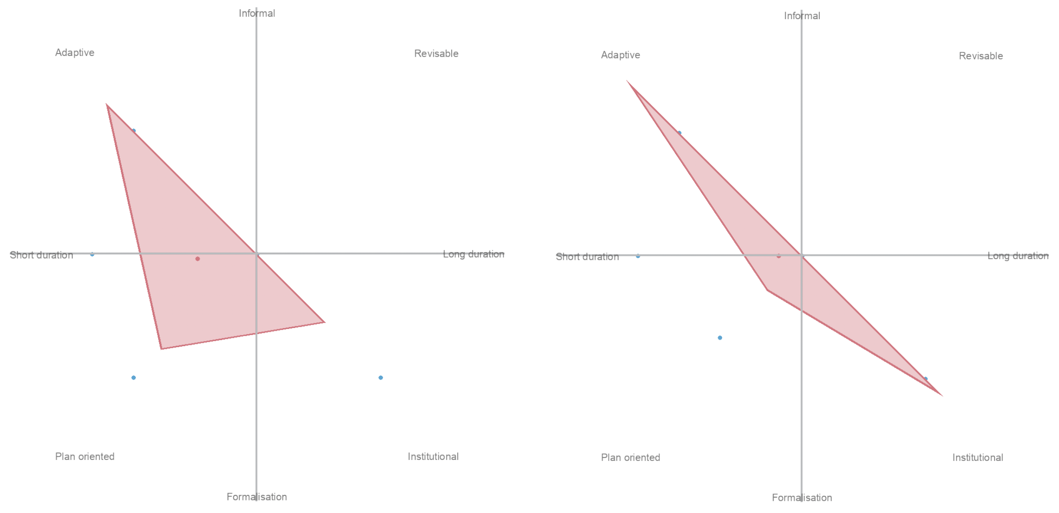

metadata={  
 "jdh": {  
 "module": "object",  
 "object": {  
 "type":"image",  
 "source": [  
 "Composite view of the centroid of all document placements in the collection on the typological compass."  
 ]  
 }  
 }  
}  
display(Image("media/figure2.png", width=1000), metadata=metadata)

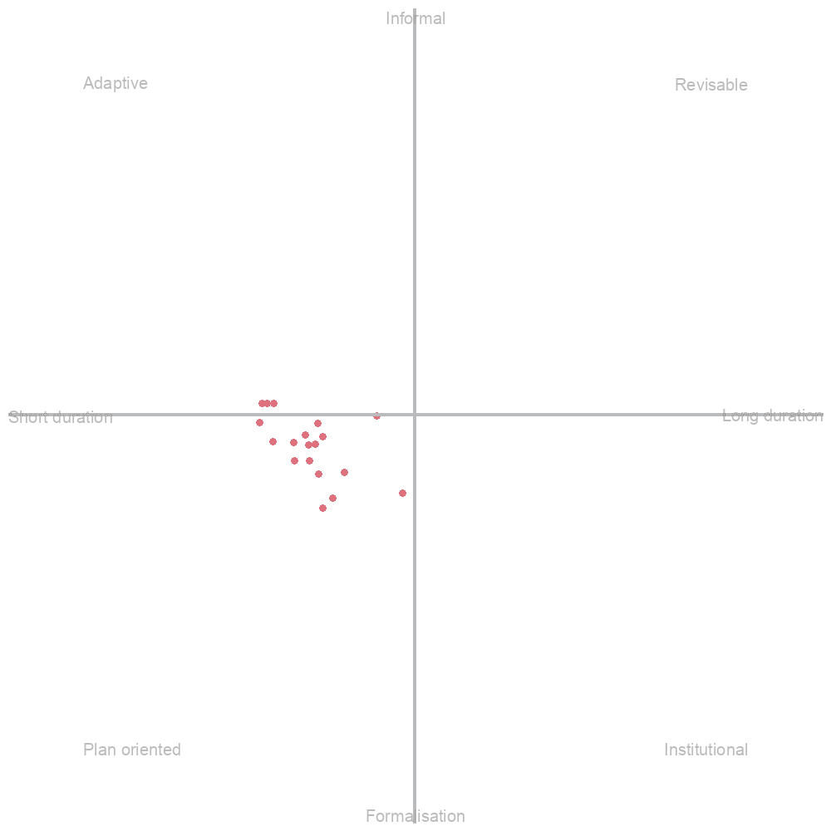

The normalizations were obtained by taking the typology matrix for each feature and getting an average for each typology. Note that we do not include the features that were not informed for the document. The absence of certain fields from some documents can weigh the visualization somewhat – we have not found a solution for accounting for this in the visualization itself, however, in the [full results](https://github.com/arvest-data-in-context/COESO-Collaborative-Analytics/blob/main/Appendix/2-Composite-Typology-Visualization-Data.json) the reader can also find the loss field for each document, which is a metric indicating the percentage of fields that were informed (a loss of 0.2 means that 80% of features were informed). This is a factor that is to be considered when interpreting the results.

### Collaboration analytics with Arvest

Looking at these vizualisations, different questions arise. For example, why are most of the documents oriented towards the *plan-oriented* typology? What are the three points in the *adaptive* category? What are the two outlying points? Before we begin to answer these questions, it is clear that a dynamic way of navigating this multidimensional data would be useful (the various dimensions are: feature value for each document; composite for each document; composite for the entire collection). This is where our tool Arvest can offer some solutions.

Levying Python scripting we can rapidly create interactive visualizations for the Arvest environment. In Figure 3, we see the data we have created loaded as a [manifest network](https://coeso.tetras-libre.fr/data/coeso-deliverable/c41b0c91-f735-41fa-83f0-d9f836bb9ca1.json) in [Arvest](https://coeso.tetras-libre.fr/). On the left, in the composite visualization of the document collection, each point on the compass is linked to an annotation which allows the reader to open the corresponding document’s Manifest in another pane in Arvest. On the right, one of these Manifests features the document in question, and also an annotation that paints the document’s typological compass below it. This allows us to rapidly navigate this multidimensional data, pivoting between different views, and even simultaneously viewing the distant and close reading perspectives.

metadata={  
 "jdh": {  
 "module": "object",  
 "object": {  
 "type":"image",  
 "source": [  
 "Manifest network derived from the collaborative typology data loaded into Arvest."  
 ]  
 }  
 }  
}  
display(Image("media/figure3.png", width=1000), metadata=metadata)

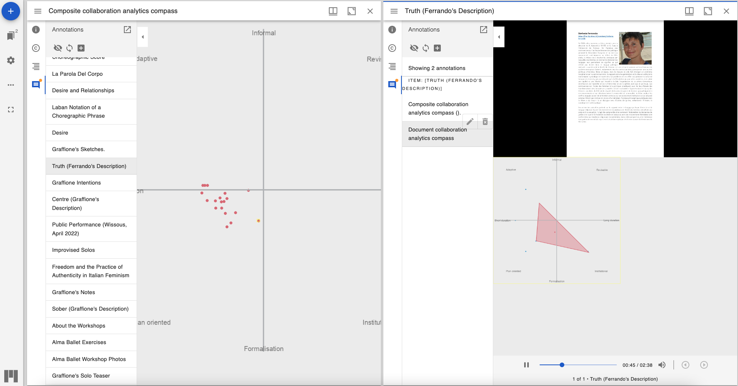

The collection tends towards the *plan-oriented* corner of the compass. This is defined by Boullier and Pidoux as consisting of collaborations of short-duration and of a relatively formalized nature. The pilot gave place to a series of short workshops which were led according to a formalized scientific method. This composite view and typological tendency confirm the suppositions that we could make about the collaborative work that occurred.

Taking a closer look, we have identified some notable points of interest which are labeled in Figure 4. We shall explore these documents using Arvest and offer some interpretation as to how they may have ended up in the places they occupy.

metadata={  
 "jdh": {  
 "module": "object",  
 "object": {  
 "type":"image",  
 "source": [  
 "Decomposition of the composite view into clusters."  
 ]  
 }  
 }  
}  
display(Image("media/figure4.png", width=1000), metadata=metadata)

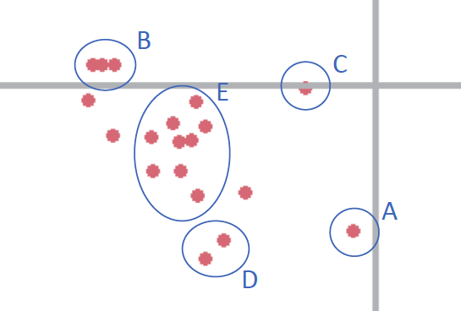

The documents in Grouping A are outliers compared to the rest of the collection of documents. They are in fact 8 documents which are all identical in typological nature, and therefore superimposed on the visualization. The 8 documents are the audio recordings made by Graffione and Ferrando that describe the movements depicted in the Laban notations around the four words *truth*, *organic*, *sober* and *center*. They all tend towards the *institutional* corner of the compass. When looking through the data, we see that this can be explained by the fact that the recordings were made specifically for a final report for the COESO Project . They are only accessible through a link that is made available through this scientific paper, and it can be argued that had they not have had to write this report, these recordings (which ‘make up’ for an absence of video documentation) would not have been made. Furthermore, they each involve one actor, speaking in their own language.

The documents in Grouping B are comprised of videos documenting work that occurred during public workshops. They are the only documents in the collection that breach the line from *plan-oriented* towards the *adaptive* corner of the compass. The contextual network of the documents is growing through reaching out to the public. They do not stray too far from the pack – indeed, as open and adaptive as these workshops need to be, they are still run with a scientific and formalized methodology.

metadata={  
 "jdh": {  
 "module": "object",  
 "object": {  
 "type":"image",  
 "source": [  
 "Local compass placement of Ferrando's notebooks."  
 ]  
 }  
 }  
}  
display(Image("media/figure5.png", width=1000), metadata=metadata)

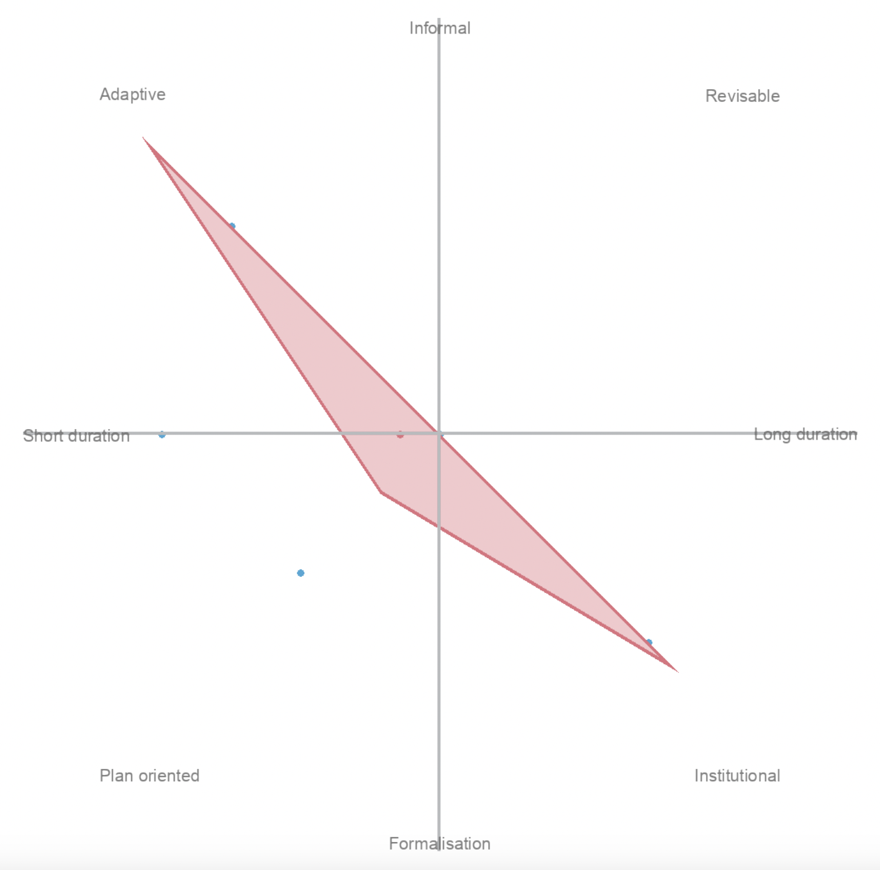

Grouping C describes two documents: photos of *Graffione* and *Ferrando’s notebooks*. Their positions on the compass throw light on an eventual limit to the methods we are exploring. When looking at the local typological compass (see Figure 5), we see that the documents in fact tend extremely towards the adaptive and institutional corners of the compass, hence the final position which is derived as the centroid of all informed fields. Note also that these documents have an extreme *loss* factor: 0.46, meaning that barely half of the fields could actually be informed. This pushes on the importance of having access to different perspectives when looking at this kind of multidimensional, data-driven interface as quantitative analysis can sometimes hide the realities of the dataset it is describing. We can perhaps explain this typology as being derived from a low amount of plan-oriented work (these are personal notebooks in which the actor writes in an ad hoc manner).

Grouping D is comprised of textual documents such as *Graffione’s intentions* and *Laban Notations*. These documents tend the most towards the *plan-oriented* corner of the compass. Indeed, they either derive from or state a somewhat rigid methodology that steers the document away from the adaptive side of the scale. The *Laban notations* notably also require an expert knowledge to be interpreted, and therefore tend the document away from *adaptability* and *openness*. These are also documents created by a sole author.

Finally, Grouping E is comprised of an ad hoc collection of documents and can be considered to represent the general tendency of the collection’s typology. We notably find textual documents that offer overviews of the Pilot’s workings and methods such as *Choreographic score*, *About the workshops*, *About silence*, *La parola del corpo* and *Desire and relationships* as well as the two video documents that are made as teasers for the project. Their central position can therefore be accounted for by their global perspective on the project.

## Conclusion

To answer to the challenge of interpreting digital traces in a digital environment, combining qualitative and quantitative methods, traditional and innovative approaches, we propose Arvest, a solution dedicated first to historians but which can be of interest to other fields. This paper presents the history and the different development phases which structured the development, as well the main issues Arvest has faced and its specifications. The development, based on a co-design approach, is ongoing, along with case studies. We presented a case study based on the COESO project. We adopted Boullier and Pidoux’s model of collaborative analytics, and examined if it was possible to apply this model to a collection of multimodal documents. The possibilities offered by Arvest allowed us to navigate our multidimensional, data-driven interface and interrogate the documents in new ways. The multiple layers of analysis engendered an analytical process that encouraged new ways of perceiving the corpus. Essentially, the visualizations were a means of rendering and engaging with the researchers’ own subjective inflections and suppositions around a corpus in a structured manner.

A prototype of Arvest is already available and a beta version will be released by the end of 2024. It is part of the ongoing development of the ERC-funded project From Stage to Data, the Digital Turn of Contemporary Performing Arts Historiography (STAGE). Arvest will be used to model creative processes and particularly their collaborative dimension, taking into account not only the rehearsals but also all the data produced by the team members. The major point in terms of development going forward for Arvest is a need to dynamically create bespoke interfaces like the network and composite typological interfaces shown in the COESO case study. These interfaces are a powerful tool to access many different data-driven perspectives on the collection. As demonstrated with the typological compass, the nature of these interfaces will differ according to the type of analysis and research question being carried out. It will be of utmost importance to offer tools for the programmatic and manual creation of these interfaces within the tool going forward.

## Acknowledgments

Funded by the European Union (ERC, STAGE, grant agreement no. 101097091). Views and opinions expressed are however those of the authors only and do not necessarily reflect those of the European Union or the European Research Council. Neither the European Union nor the granting authority can be held responsible for them.

Avec le soutien de la Région Bretagne.

Avec le soutien de Ouest Valorisation, Société d’Accélération du Transfert de Technologies.